2. Git-HOL:
Step 1: go to the working directory & create .log file and log folder
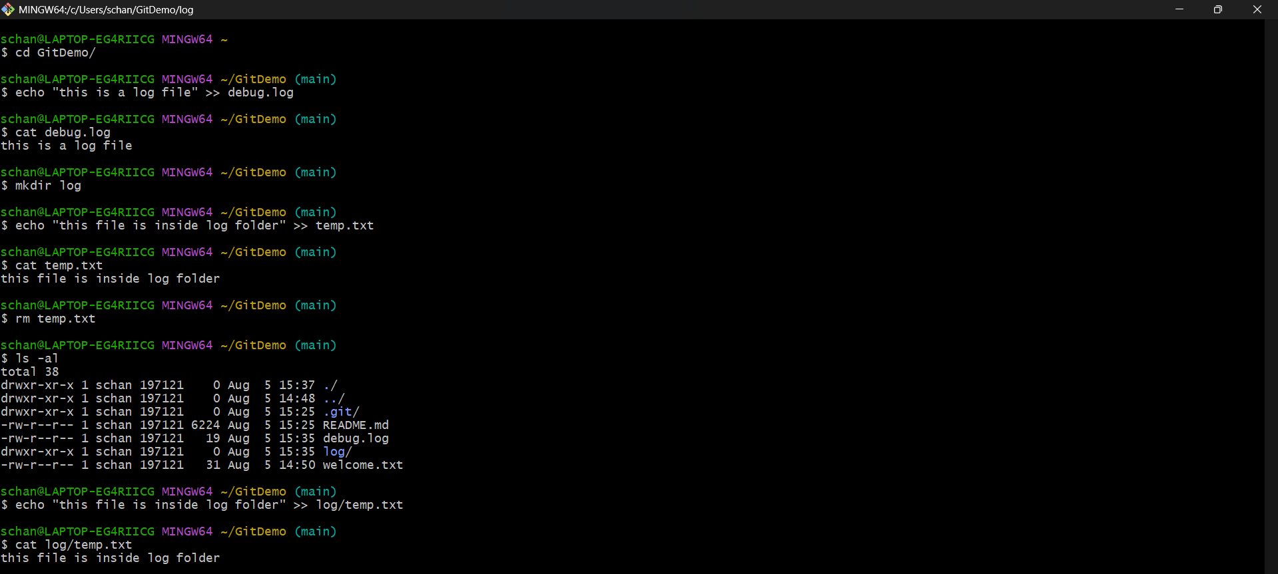
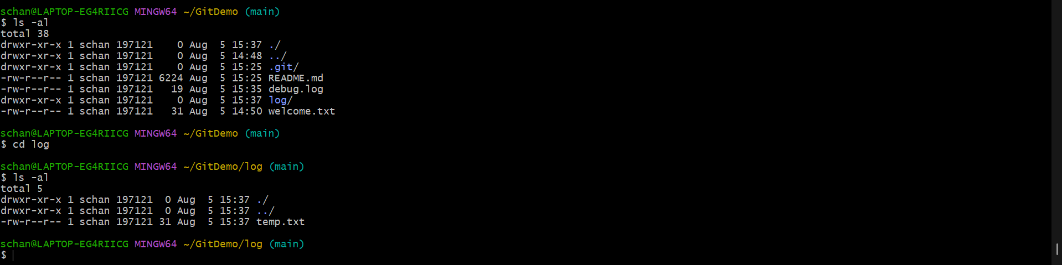
Step2: create .gitignore file and add the things to ignore.
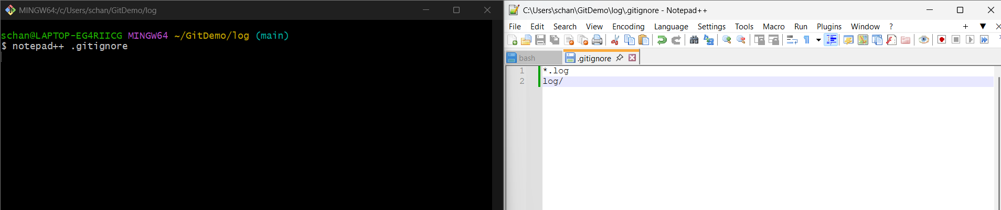
Step3: add the gitignore file to staging area and commit it.
